February 12, 2021
Franklin County Homicides
Comparison Period: January-September 2019 vs. January-September 2020

In Franklin County, from January to September 2019 to 2020, there was a 40.4% increase in Homicides. From January -September 2019 in Franklin County there were 94 homicide deaths as compared to 132 homicides deaths for the same time period for 2020.

Gender:

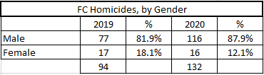

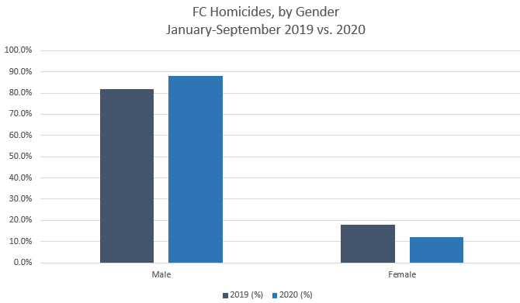

Race/Ethnicity:

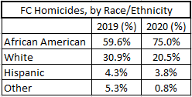

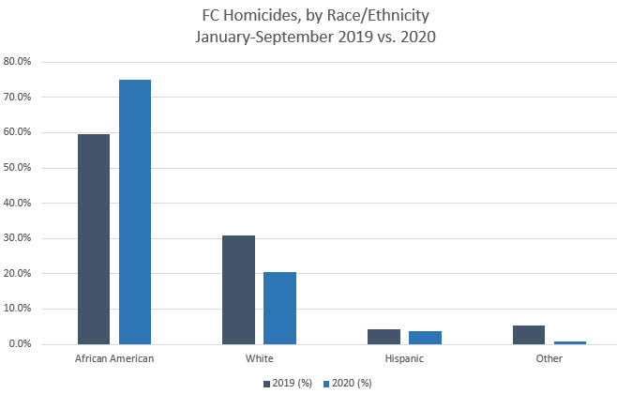

Age Range:

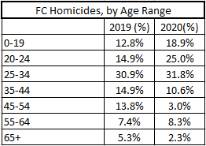

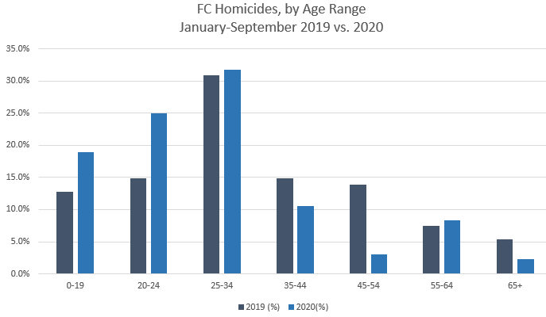

Method:

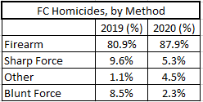

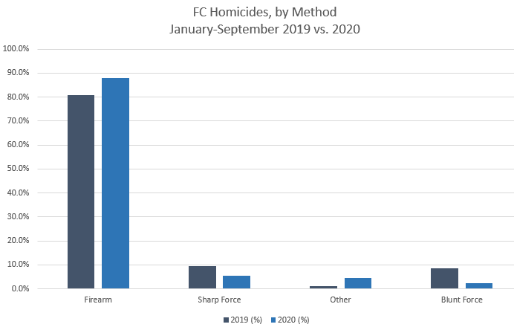

Top Zip Codes:

